Part 2: Relationship between radiologic/clinicopathologic features and survival time (univariate analysis)

Objective: Define the features which affect the prognosis of lung squamous cell carcinoma survival time

Methods used:
- Cox Proportional Hazards Regression Model: explore the relationships between the survival time and explanatory variables.
- Kaplan-Meier estimator: estimate the survival function and visualize probability of an event at a certain time interval.
- Logrank test: compare the survival between groups of populations.

Results and discussion:
Relationship between each features and death status is showed in Table 3.

Part2. A. Cox Proportional Hazards Regression Model fit

The Cox regression results can be interpreted as follow:

1. Statistical significance:
The Wald statistic value z corresponds to the ratio of each regression coefficient to its standard error (z = coef/se(coef)). The Wald statistic evaluates whether the beta (β) coefficient of a given variable is statistically significantly different from 0.

2. The regression coefficient:
The second feature to note in the Cox model results is the sign of the regression coefficients (coef). A positive sign means that the hazard (risk of death) is higher, and thus the prognosis worse, for subjects with higher values of that variable. The R summary for the Cox model gives the hazard ratio (HR) for the second group relative to the first group.

3. Hazard ratios (HR):
The exponentiated coefficient (exp(coef)) gives the effect size of covariates.

4. Confidence intervals of the hazard ratios:
The summary output also gives upper and lower 95% confidence intervals for the hazard ratio (exp(coef)).

5. Global statistical significance of the model:
Finally, the output gives p-values for three alternative tests for overall significance of the model: The likelihood-ratio test, Wald test, and score Logrank statistics. These three methods are asymptotically equivalent. For large enough N, they will give similar results. For small N, they may differ somewhat. The Likelihood ratio test has better behavior for small sample sizes, so it is generally preferred.

Thanks to these results, we can decide to reject or keep covariates for the upcoming study based on their statistical significance.

We here split the analysis into two groups of features:
- Radiologic features
- Clinicopathologic features

Part2. A. 1. Relationship between radiologic features and survival time

Features to be analyzed in this part:

1. Location vs OS: tumor location
2. Obst_pn_or_plugging vs OS: patients with or without obstructive pneumonitis/atelectasis
3. Necrosis vs OS: patients with or without cell necrosis or cavitation observed
4. Underlying_lung vs OS: the type of underlying lung disease observed
5. Effusion vs OS: patient with or without observed lung effusion

The p-values of Location (0.09), Obst_pn_or_plugging (0.1), Necrosis (0.05) and effusion (0.9) are too high to consider these features as statistically significant. We then reject the use of these four covariates for the upcoming study. (see code in supporting information)

However, with a very low p-value of 3.93e-10 and a positive coefficient of 1.61, we can assume that there is a highly significant positive relationship between survival time (OS) and Interstitial lung abnormalities (ILA). With a value of 1.61, the sign of the regression coefficient for ILA is positive which means that the hazard (risk of death) is higher, and thus the prognosis worse, for subjects with higher values of that variable. The beta coefficient for ILA=1.61 indicates that patients with ILA have higher risk of death (lower survival rates) than patients with emphysema. The exponentiated coefficient (exp(coef)=exp(1.61)=5.00) gives the effect size of covariates. Here, a patient with ILA increases the hazard by a factor of 5.00, or 400%. Having ILA is indeed associated with bad prognostic. Moreover, the summary output also gives upper and lower 95% confidence intervals (CI) for the hazard ratio (exp(coef)) as follows: lower 95% bound=3.02, upper 95% bound=8.28 for ILA. (see code in supporting information)

To conclude, we decide to select Underlying_lung as a significant covariate for the upcoming study.

Part2. A. 2. Relationship between clinicopathologic features and survival time

Features to be analyzed in this part:

1. Sex vs OS: gender of the patient
2. AG vs OS: age of the patient at diagnosis
3. LN_ratio vs OS: lymph node ratio
4. cT vs OS: central lung SCC size of tumor
5. cN vs OS: when nearby lymph nodes are involved
6. cM vs OS: when distant metastasis are involved
7. pT vs OS: peripheral lung SCC size of tumor
8. pN vs OS: when nearby lymph nodes are involved
9. pM vs OS: when distant metastasis are involved
10. Smoking_state vs OS: current smoking state of the patient
11. FEV1_FVC vs OS: pulmonary function test
12. CEA vs OS: serum carcinoembryonic antigen level
13. OP vs OS: the type of operation undergone by the patient
14. meta vs OS: patient with and without observed metastasis after surgery

The p-values of Sex (0.5), cM (0.7), Smoking_state (0.2), FEV1_FVC (0.1) and CEA (0.6) are too high to consider these features as statistically significant. We then reject the use of these five covariates for the upcoming study. (see code in supporting information)

Also, the repartition of the population in the groups is too unbalanced for the LN_ratio and the OP covariates so these features will also be rejected for the next steps of the study. (see code in supporting information)

However, with a low p-value of 0.001 and a positive coefficient of 0.70, we can assume that there is a statistically significant positive relationship between survival time (OS) and age over 60. With a value of 0.70, the sign of the regression coefficient for age over 60 is positive which means that the hazard (risk of death) is higher, and thus the prognosis worse, for subjects with higher values of that variable. The beta coefficient for age over 60=0.70 indicates that patients aged over 60 have higher risk of death (lower survival rates) than younger patients. The exponentiated coefficient (exp(coef)=exp(0.70)=2.01) gives the effect size of covariates. Here, a patient older than 60 increases the hazard by a factor of 2.01, or 101%. Being older than 60 is indeed associated with bad prognostic. Moreover, the summary output also gives upper and lower 95% confidence intervals (CI) for the hazard ratio (exp(coef)) as follows: lower 95% bound=1.33, upper 95% bound=3.06 for age over 60. (see code in supporting information)

With a low p-value of 2.99e-05 and a positive coefficient of 1.14, we can assume that there is a statistically significant positive relationship between survival time (OS) and cT3. With a value of 1.14, the sign of the regression coefficient for cT3 is positive which means that the hazard (risk of death) is higher, and thus the prognosis worse, for subjects with higher values of that variable. The beta coefficient for cT3=1.14 indicates that patients with cT3 have higher risk of death (lower survival rates) than patients with cT1. The exponentiated coefficient (exp(coef)=exp(1.14)=3.14) gives the effect size of covariates. Here, a patient with cT3 increases the hazard by a factor of 3.14, or 214%. Having cT3 is indeed associated with bad prognostic. Moreover, the summary output also gives upper and lower 95% confidence intervals (CI) for the hazard ratio (exp(coef)) as follows: lower 95% bound=1.84, upper 95% bound=5.38 for cT3. (see code in supporting information)

With a low p-value of 0.0003 and a positive coefficient of 0.77, we can assume that there is a statistically significant positive relationship between survival time (OS) and cN2. With a value of 0.77, the sign of the regression coefficient for cN2 is positive which means that the hazard (risk of death) is higher, and thus the prognosis worse, for subjects with higher values of that variable. The beta coefficient for cN2=0.77 indicates that patients with cN2 have higher risk of death (lower survival rates) than patients with cN0. The exponentiated coefficient (exp(coef)=exp(0.77)=2.16) gives the effect size of covariates. Here, a patient with cN2 increases the hazard by a factor of 2.16, or 116%. Having cN2 is indeed associated with bad prognostic. Moreover, the summary output also gives upper and lower 95% confidence intervals (CI) for the hazard ratio (exp(coef)) as follows: lower 95% bound=1.42, upper 95% bound=3.29 for cN2. (see code in supporting information)

With a low p-value of 0.007 and a positive coefficient of 0.69, we can assume that there is a statistically significant positive relationship between survival time (OS) and pT3. With a value of 0.69, the sign of the regression coefficient for pT3 is positive which means that the hazard (risk of death) is higher, and thus the prognosis worse, for subjects with higher values of that variable. The beta coefficient for pT3=0.69 indicates that patients with pT3 have higher risk of death (lower survival rates) than patients with pT1. The exponentiated coefficient (exp(coef)=exp(0.69)=1.99) gives the effect size of covariates. Here, a patient with pT3 increases the hazard by a factor of 1.99, or 99%. Having pT3 is indeed associated with bad prognostic. Moreover, the summary output also gives upper and lower 95% confidence intervals (CI) for the hazard ratio (exp(coef)) as follows: lower 95% bound=1.20, upper 95% bound=3.30 for pT3. (see code in supporting information)

With a low p-value of 1.51e-05 and a positive coefficient of 0.86, we can assume that there is a statistically significant positive relationship between survival time (OS) and pN2. With a value of 0.86, the sign of the regression coefficient for pN2 is positive which means that the hazard (risk of death) is higher, and thus the prognosis worse, for subjects with higher values of that variable. The beta coefficient for pN2=0.86 indicates that patients with pN2 have higher risk of death (lower survival rates) than patients with pN0. The exponentiated coefficient (exp(coef)=exp(0.86)=2.37) gives the effect size of covariates. Here, a patient with pN2 increases the hazard by a factor of 2.37, or 137%. Having pN2 is indeed associated with bad prognostic. Moreover, the summary output also gives upper and lower 95% confidence intervals (CI) for the hazard ratio (exp(coef)) as follows: lower 95% bound=1.60, upper 95% bound=3.50 for pN2. (see code in supporting information)

With a low p-value of 0.0005 and a positive coefficient of 1.77, we can assume that there is a statistically significant positive relationship between survival time (OS) and pM1b. With a value of 1.77, the sign of the regression coefficient for pM1b is positive which means that the hazard (risk of death) is higher, and thus the prognosis worse, for subjects with higher values of that variable. The beta coefficient for pM1b=1.77 indicates that patients with pM1b have higher risk of death (lower survival rates) than patients with pM0. The exponentiated coefficient (exp(coef)=exp(1.77)=5.85) gives the effect size of covariates. Here, a patient with pM1b increases the hazard by a factor of 5.85, or 485%. Having pM1b is indeed associated with bad prognostic. Moreover, the summary output also gives upper and lower 95% confidence intervals (CI) for the hazard ratio (exp(coef)) as follows: lower 95% bound=2.16, upper 95% bound=15.84 for pM1b. (see code in supporting information)

With a low p-value of 5.22e-08 and a positive coefficient of 0.85, we can assume that there is a statistically significant positive relationship between survival time (OS) and the observation of metastasis. With a value of 0.85, the sign of the regression coefficient for observed metastasis is positive which means that the hazard (risk of death) is higher, and thus the prognosis worse, for subjects with higher values of that variable. The beta coefficient for observed metastasis=0.85 indicates that patients with observed metastasis have higher risk of death (lower survival rates) than patients without metastasis. The exponentiated coefficient (exp(coef)=exp(0.85)=2.33) gives the effect size of covariates. Here, a patient with observed metastasis increases the hazard by a factor of 2.33, or 133%. Observed metastasis is indeed associated with bad prognostic. Moreover, the summary output also gives upper and lower 95% confidence intervals (CI) for the hazard ratio (exp(coef)) as follows: lower 95% bound=1.72, upper 95% bound=3.16 for observed metastasis. (see code in supporting information)

To conclude, we decide to select Underlying_lung , AG, cT, cN, pT, pN, pM, and meta as significant covariates for the upcoming study.

Table 3: Relationship between radiologic/clinicopathologic features and survival time (univariate analysis)
Variables | Comparison group(s) | Reference group | P-value | HR [95% CI]
Radiologic variables
Location | Peripheral | Central | 0.0891 | 1.304 [ 0.9602-1.771]
Obstructive pneumonitis/atelectasis | Present | Absent | 0.099 | 0.7765 [0.575-1.049]
Necrosis | Necrosis | NoRemark | 0.110 | 1.310 [0.9402-1.826]
Necrosis | Cavitation | NoRemark | 0.033 | 1.774 [1.0473-3.006]
Underlying lung disease | Emphysema | NoRemark | 0.0255 | 1.494 [1.051-2.125]
Underlying lung disease | ILA | NoRemark | 3.93e-10 | 5.001 [3.020-8.280]
Effusion | Present | Absent | 0.917 | 0.9486 [0.3518-2.557]
Clinicopathologic variables
Sex | M | F | 0.481 | 0.7619 [0.3574-1.624]
Age | OV60 | LT60 | 0.00103 | 2.015 [1.326-3.062]
Lymph node ratio | numerical value |  | 0.00956 | 2.329 [1.229-4.414]
cT | cT2 | cT1 | 0.1236 | 1.445 [0.9044-2.310]
cT | cT3 | cT1 | 2.99e-05 | 3.144 [1.8361-5.384]
cT | cT4 | cT1 | 0.0642 | 2.092 [0.9574-4.573]
cN | cN1 | cN0 | 0.634426 | 1.107 [0.7276-1.685]
cN | cN2 | cN0 | 0.000321 | 2.162 [1.4205-3.291]
cN | cN3 | cN0 | 0.218450 | 1.872 [0.6896-5.085]
cM | cM1b | cM0 | 0.667 | 1.54 [0.2155-11]
pT | pT2 | pT1 | 0.20657 | 1.339 [0.8512-2.106]
pT | pT3 | pT1 | 0.00787 | 1.988 [1.1976-3.299]
pT | pT4 | pT1 | 0.20356 | 1.873 [0.7118-4.930]
pN | pN1 | pN0 | 0.1864 | 1.281 [0.887-1.851]
pN | pN2 | pN0 | 1.51e-05 | 2.367 [1.602-3.498]
pN | pN3 | pN0 | 0.0493 | 3.181 [1.004-10.084]
pM | pM1b | pM0 | 0.000504 | 5.854 [2.163-15.84]
Smoking state | Current smoker | Non-smoker | 0.103 | 1.984 [0.8708-4.520]
Smoking state | Ex-smoker | Non-smoker | 0.345 | 1.466 [0.6625-3.243]
Smoking state | Unknown | Non-smoker | 0.122 | 1.838 [0.8507-3.969]
FEV1FVC | numerical value |  | 0.131 | 1.01 [0.9969-1.024]
CEA | numerical value |  | 0.604 | 0.9979
Operation type | Lobectomy | No op | 0.0925 | 0.3007 [0.07415-1.219]
Operation type | Pneumonectomy | No op | 0.2076 | 0.3964 [0.09400-1.672]
Operation type | Segmentectomy | No op | 0.2143 | 0.2183 [0.01976-2.411]
Operation type | LN biopsy | No op | 0.6951 | 1.3522 [0.29915-6.112]
Metastasis | Present | Absent | 5.22e-08 | 2.332 [1.719-3.163]

Part2. B. Kaplan-Meier estimator and Logrank test with features which have a significant relationship with survival time

List of features which have a significant relationship with survival time (OS):

1. Comparison between 2 groups of patients based on underlying lung disease
2. Comparison between 2 groups of patients based on their age
3. Comparison between 2 groups of patients based on central lung SCC size of tumor
4. Comparison between 2 groups of patients based on cN when nearby lymph nodes are involved
5. Comparison between 2 groups of patients based on peripheral lung SCC size of tumor
6. Comparison between 2 groups of patients based on pN when nearby lymph nodes are involved
7. Comparison between 2 groups of patients based on pM when distant metastasis are involved
8. Comparison between 2 groups of patients based on the observation of metastasis after surgery

The Logrank test result doesn't show a significant difference in survival between groups of patients according to the peripheral lung SCC size of tumor (p-value=0.04).
We then reject the use of the pT covariate. (see code in supporting information)

1. Comparison between 2 groups of patients based on underlying lung disease
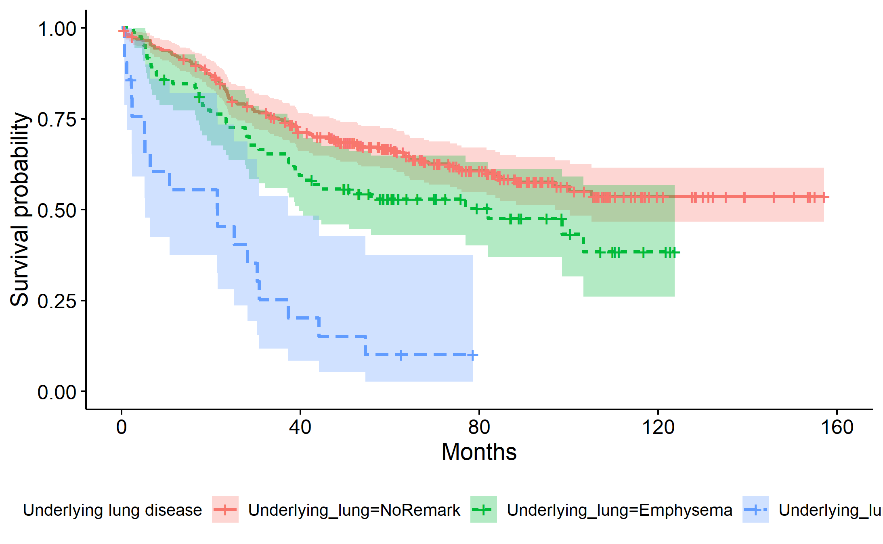
Among a total of 292 patients without underlying lung disease, 111 of them died.
Among a total of 85 patients with emphysema, 43 of them died with 40% chance of death at 82 months.
Among a total of 21 patients with ILA, 18 of them died with 5% chance of death at 21.5 months.
Logrank test result shows a significant difference in survival between these groups of patients (p=4e-11).

(see code in supporting information)

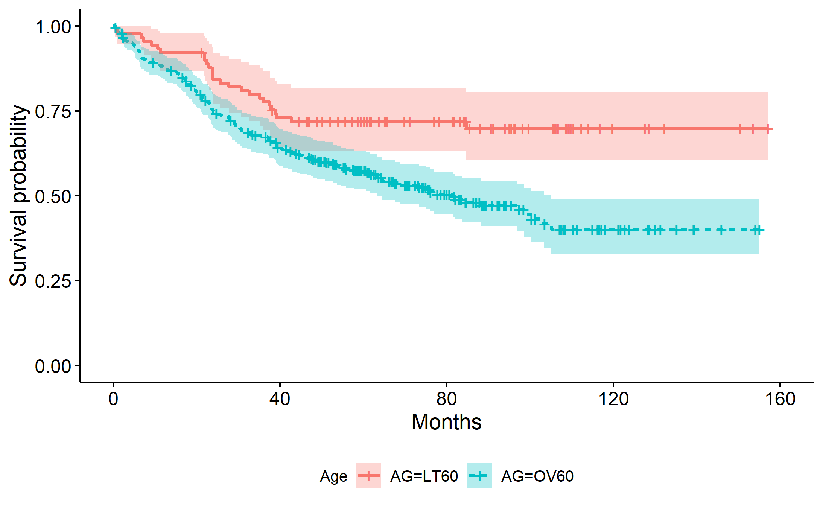
2. Comparison between 2 groups of patients based on their age

Among a total of 90 patients below the age of 60, 26 of them died.
Among a total of 308 patients above the age of 60, 146 of them died with 63% chance of death at 81.6 months.
Logrank test result shows a significant difference in survival between these groups of patients (p=8e-04).
(see code in supporting information)

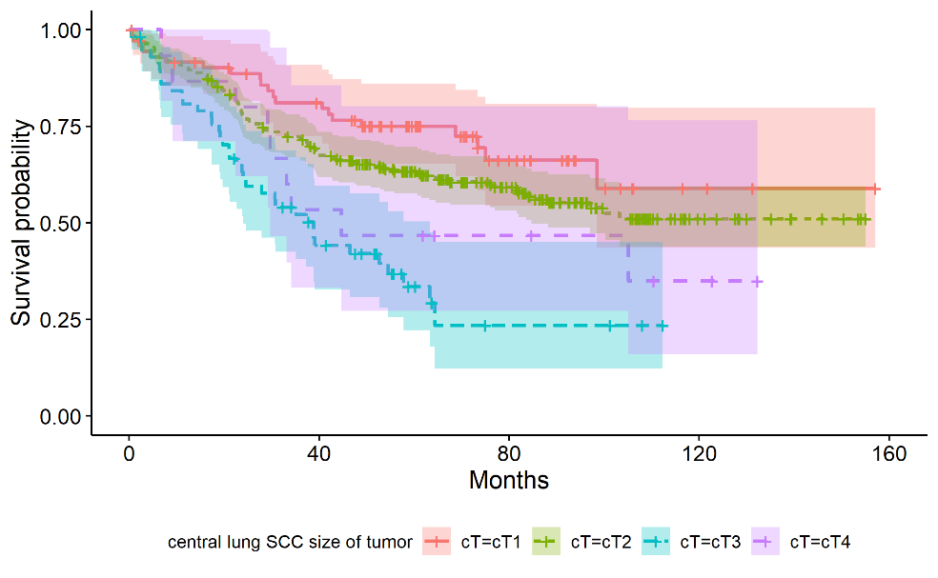
3. Comparison between 2 groups of patients based on central lung SCC size of tumor

Among a total of 73 patients with central lung SCC size of tumor T1, 21 of them died.
Among a total of 252 patients with central lung SCC size of tumor T2, 105 of them died.
Among a total of 58 patients with central lung SCC size of tumor T3, 37 of them died with 24% chance of death at 38.8 months.
Among a total of 15 patients with central lung SCC size of tumor T4, 9 of them died with 30% chance of death at 44.7 months.

Logrank test result shows a significant difference in survival between these groups of patients (p=3e-05). (see code in supporting information)

4. Comparison between 2 groups of patients based on cN when nearby lymph nodes are involved

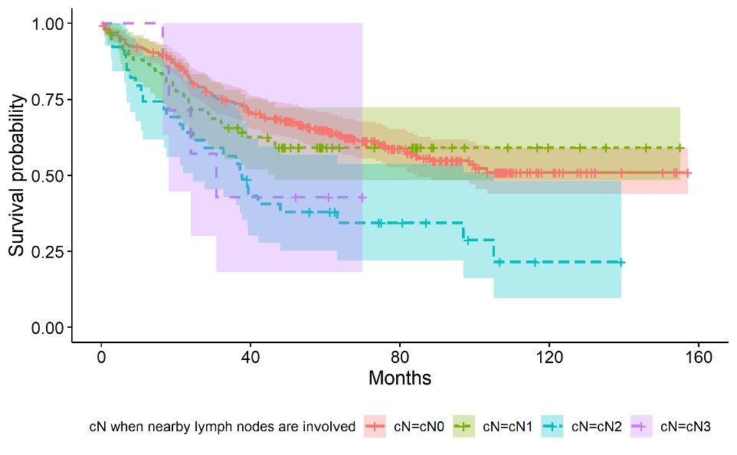
Among a total of 284 patients with N0 central nearby lymph nodes involved, 114 of them died.
Among a total of 68 patients with N1 central nearby lymph nodes involved, 27 of them died.
Among a total of 39 patients with N2 central nearby lymph nodes involved, 27 of them died with 25% chance of death at 37.6 months.
Among a total of 7 patients with N3 central nearby lymph nodes involved, 4 of them died with 18% chance of death at 30.8 months.
Logrank test result shows a significant difference in survival between these groups of patients (p=0.002). (see code in supporting information)

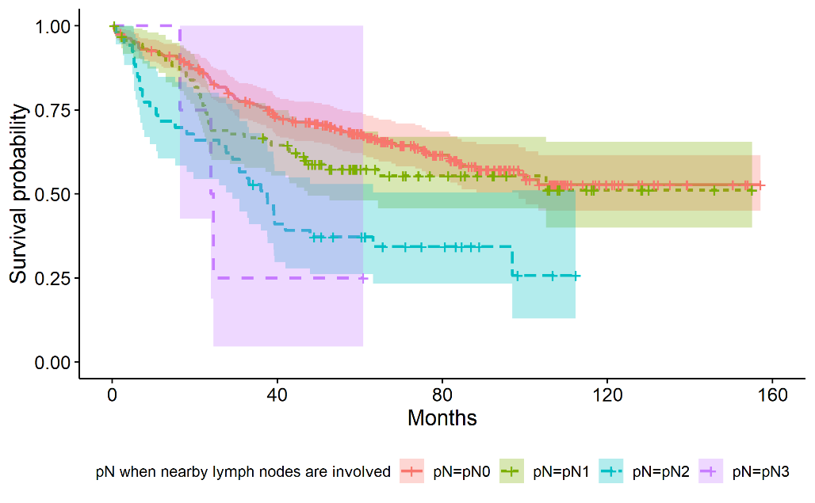
6. Comparison between 2 groups of patients based on pN when nearby lymph nodes are involved

Among a total of 246 patients with N0 peripheral nearby lymph nodes involved, 93 of them died.
Among a total of 95 patients with N1 peripheral nearby lymph nodes involved, 41 of them died.
Among a total of 53 patients with N2 peripheral nearby lymph nodes involved, 35 of them died with 30% chance of death at 37.5 months.
Among a total of 4 patients with N3 peripheral nearby lymph nodes involved, 3 of them died with 16% chance of death at 24.2 months.
Logrank test result shows a significant difference in survival between these groups of patients (p=5e-05). (see code in supporting information)

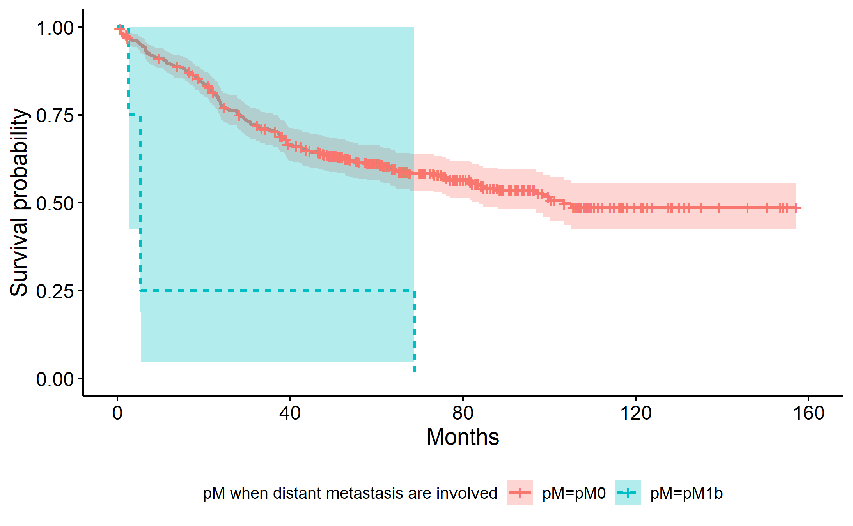
7. Comparison between 2 groups of patients based on pM when distant metastasis are involved

Among a total of 394 patients with M0 peripheral distant metastasis involved, 168 of them died with 84% chance of death at 103.3 months.
Among a total of 4 patients with M1b peripheral distant metastasis involved, all of them died with 3% chance of death at 5.35 months.
Logrank test result shows a significant difference in survival between these groups of patients (p=8e-05).
(see code in supporting information)

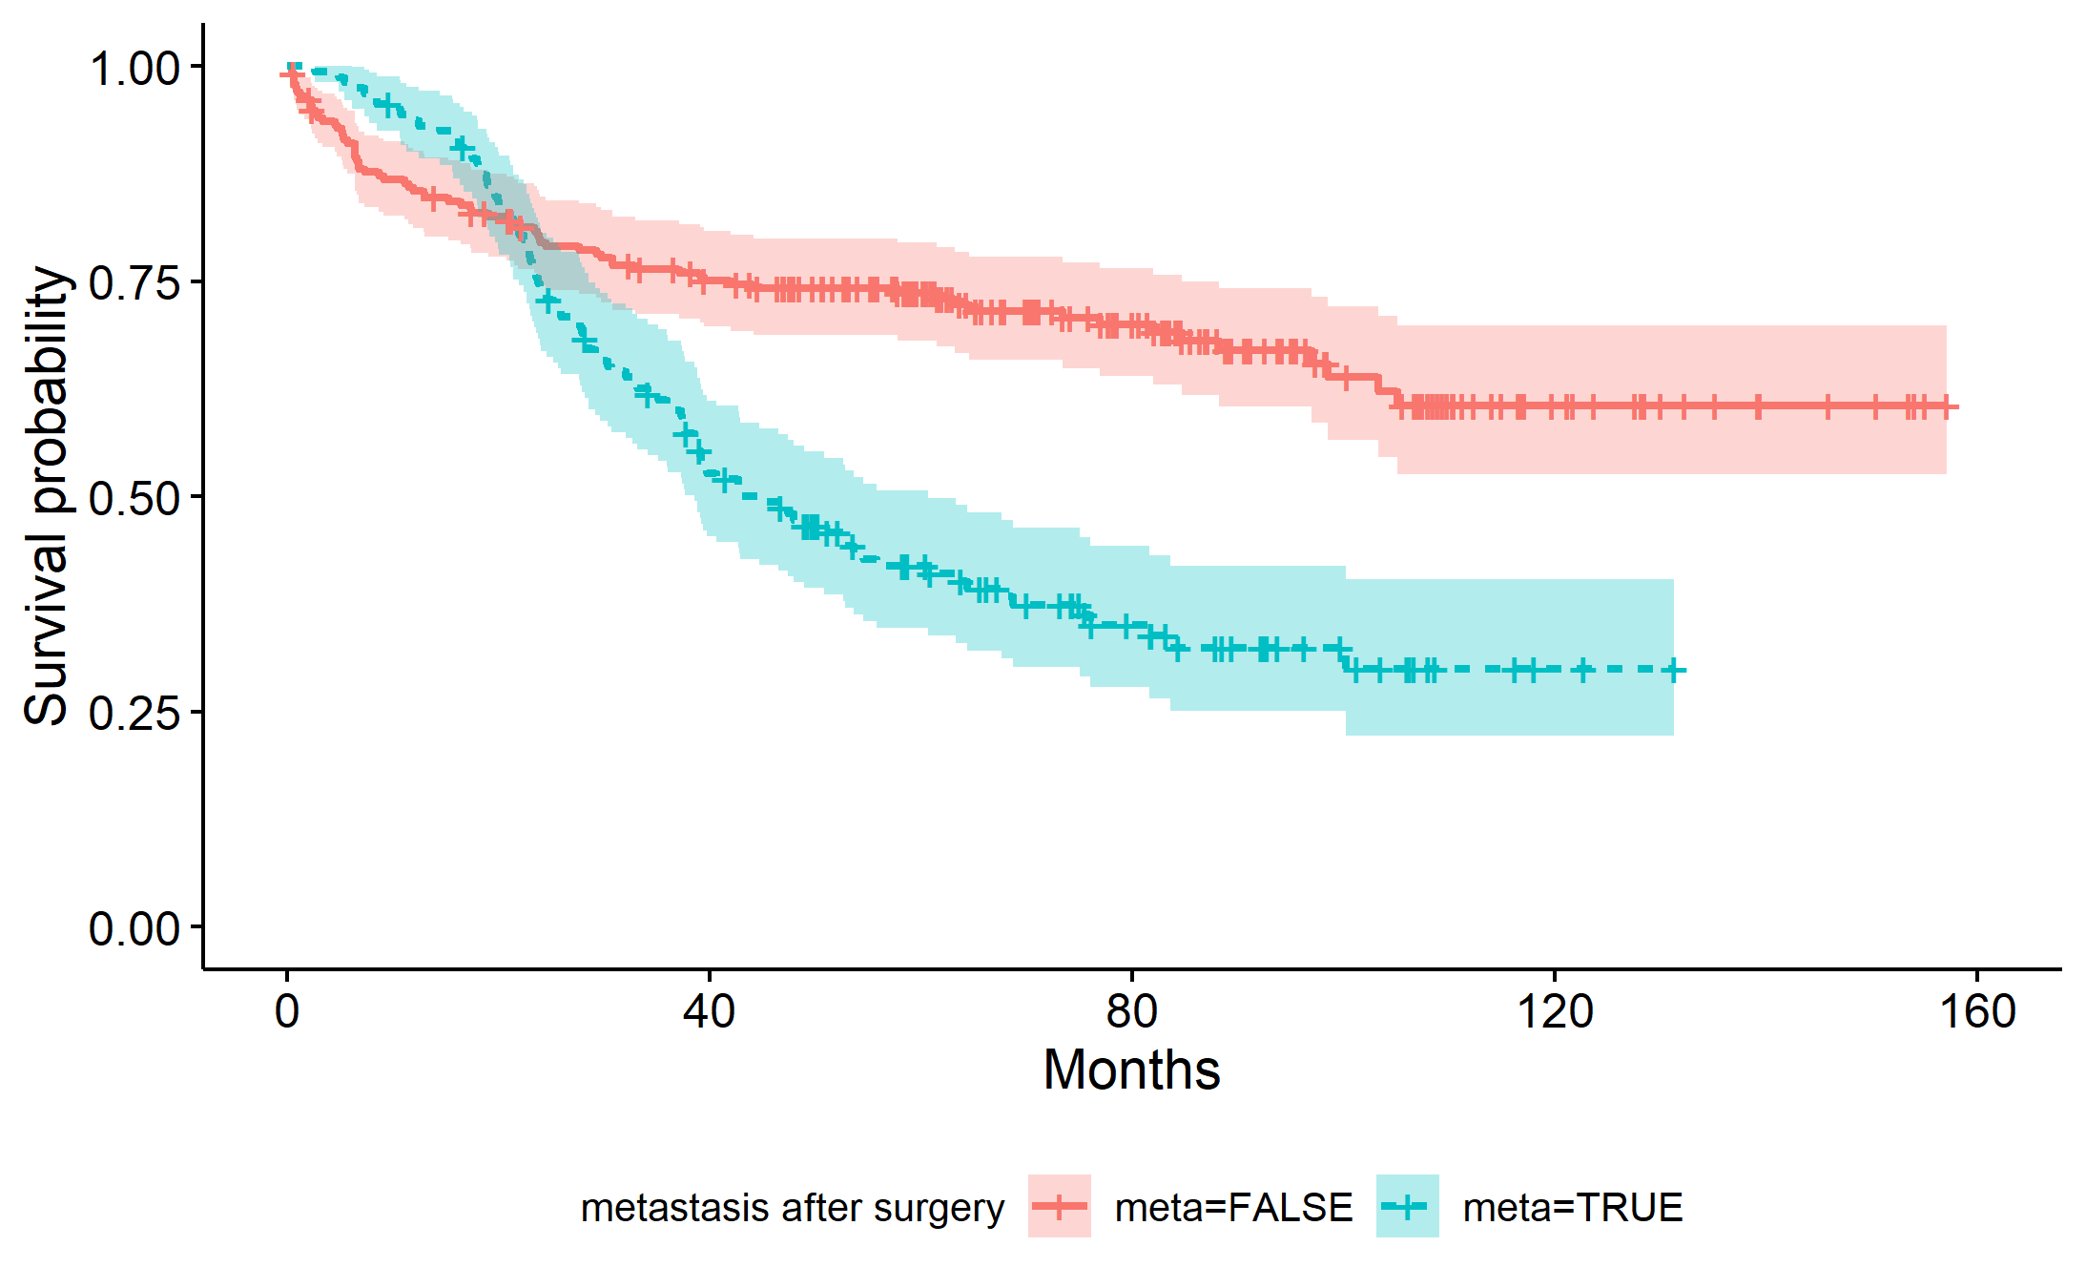
8. Comparison between 2 groups of patients based on the observation of metastasis after surgery

Among a total of 238 patients without observed metastasis, 73 of them died.
Among a total of 160 patients with observed metastasis, 99 of them died with 38% chance of death at 44.7 months.
Logrank test result shows a significant difference in survival between these groups of patients (p=2e-08).
(see code in supporting information)

To conclude, we decide to select the 7 following variable Underlying_lung , AG, cT, cN, pN, pM, and meta as significant features for the upcoming study.

Code for part 2:

library(tidyverse)
library(survival)
library(survminer)
library(asaur)
Data preparation: load the lung cancer dataset and check data types
lungSCC_raw <- read_csv("../LungCancer.csv",
col_types=cols(Sex='c',
Age='c',
Location='d',
Obst_pn_or_plugging='d',
Necrosis='d',
Underlying_lung='d',
Effusion='d',
LN_ratio='d',
cT='c',
cN='c',
cM='c',
pT='c',
pN='c',
pM='c',
Smoking_state='c',
FEV1_FVC='d',
CEA='d',
op_type='c',
death='d',
OP_site_recur='l',
meta='l',
OS = "d",
.default = 'c'))
Explore the dataset:
dim(lungSCC_raw)
# Radiologic features
table(lungSCC_raw$Location, useNA="always")
table(lungSCC_raw$Obst_pn_or_plugging, useNA="always")
table(lungSCC_raw$Necrosis, useNA="always")
table(lungSCC_raw$Underlying_lung, useNA="always")
table(lungSCC_raw$Effusion, useNA="always")
# Clinicopathologic features
table(lungSCC_raw$Sex, useNA="always")
table(lungSCC_raw$AG, useNA="always")
summary(lungSCC_raw$AG)
table(lungSCC_raw$LN_ratio, useNA="always")
summary(lungSCC_raw$LN_ratio)
table(lungSCC_raw$cT, useNA="always")
table(lungSCC_raw$cN, useNA="always")
table(lungSCC_raw$cM, useNA="always")
table(lungSCC_raw$pT, useNA="always")
table(lungSCC_raw$pN, useNA="always")
table(lungSCC_raw$pM, useNA="always")
table(lungSCC_raw$Smoking_state, useNA="always")
table(lungSCC_raw$FEV1_FVC, useNA="always")
summary(lungSCC_raw$FEV1_FVC)
table(lungSCC_raw$CEA)
summary(lungSCC_raw$CEA)
table(lungSCC_raw$OP, useNA="always")
table(lungSCC_raw$death, useNA="always")
table(lungSCC_raw$meta, useNA="always")
table(lungSCC_raw$OS, useNA="always")
summary(lungSCC_raw$OS)
Redefine the meaning of each label to make it easier for interpretation
lungSCC <- mutate(lungSCC_raw,
Location=ifelse(Location==0, "Peripheral", "Central"),
Sex=factor(Sex, levels=c("F", "M")),
Necrosis = factor(Necrosis, levels = c("0", "1", "2"), labels = c("NoRemark", "Necrosis", "Cavitation")),
Necrosis <- relevel(Necrosis, "NoRemark"),
Underlying_lung = factor(Underlying_lung, levels = c("0", "1", "2"), labels = c("NoRemark", "Emphysema", "ILA")),
Underlying_lung <- relevel(Underlying_lung, "NoRemark"),
Effusion=factor(Effusion, levels=c("0", "1"), labels=c("Absent", "Present")),
AG = ifelse((Age<60), "LT60", "OV60"),
AG = factor(AG),
OP = factor(op_type, levels = c("5", "1", "2", "3", "4"), labels = c("No op", "Lobectomy", "Pneumonectomy", "Segmentectomy", "LN biopsy")),
OP <- relevel(OP, "No op"),
Smoking_state = factor(Smoking_state, levels = c("3", "0", "1", "2"), labels = c("Non-smoker", "Current-smoker", "Ex-smoker", "Unknown")),
Smoking_state <- relevel(Smoking_state, "Non-smoker"),
cT = factor(cT, levels = c("1", "2", "3", "4"), labels = c("cT1", "cT2", "cT3", "cT4")),
cN = factor(cN, levels = c("1", "2", "3", "4"), labels = c("cN0", "cN1", "cN2", "cN3")),
cM = factor(cM, levels = c("1", "3"), labels = c("cM0", "cM1b")),
pT = factor(pT, levels = c("1", "2", "3", "4"), labels = c("pT1", "pT2", "pT3", "pT4")),
pN = factor(pN, levels = c("1", "2", "3", "4"), labels = c("pN0", "pN1", "pN2", "pN3")),
pM = factor(pM, levels = c("1", "3"), labels = c("pM0", "pM1b")))
Part 2: Relationship between radiologic/clinicopathologic features and survival time (univariate analysis)

Part2. A. Cox Proportional Hazards Regression Model fit
Part2. A. 1. Relationship between radiologic features and survival time
- Location vs OS: tumor location:
fit_location <- coxph(Surv(OS, death) ~ Location, data=lungSCC)
summary(fit_location)
- Obst_pn_or_plugging vs OS: patients with or without obstructive pneumonitis/atelectasis:
fit_Obst_pn_or_plugging <- coxph(Surv(OS, death) ~ Obst_pn_or_plugging, data=lungSCC)
summary(fit_Obst_pn_or_plugging)
- Necrosis vs OS: patients with or without cell necrosis or cavitation observed:
fit_necrosis <- coxph(Surv(OS, death) ~ Necrosis, data=lungSCC)
summary(fit_necrosis)
- Underlying_lung vs OS: the type of underlying lung disease observed:
fit_UndLung <- coxph(Surv(OS, death) ~ Underlying_lung, data=lungSCC)
summary(fit_UndLung)
- Effusion vs OS: patient with or without observed lung effusion:
fit_effusion <- coxph(Surv(OS, death) ~ Effusion, data=lungSCC)
summary(fit_effusion)
Part2. A. 2. Relationship between clinicopathologic features and survival time
- Sex vs OS: gender of the patient:
fit_Sex <- coxph(Surv(OS, death) ~ Sex, data=lungSCC)
summary(fit_Sex)
- AG vs OS: age of the patient at diagnosis:
fit_Age <- coxph(Surv(OS, death) ~ AG, data=lungSCC)
summary(fit_Age)
- LN_ratio vs OS: lymph node ratio:
fit_LNratio <- coxph(Surv(OS, death) ~ LN_ratio, data=lungSCC)
summary(fit_LNratio)
- cT vs OS: central lung SCC size of tumor:
fit_cT <- coxph(Surv(OS, death) ~ cT, data=lungSCC)
summary(fit_cT)
- cN vs OS: when nearby lymph nodes are involved:
fit_cN <- coxph(Surv(OS, death) ~ cN, data=lungSCC)
summary(fit_cN)
- cM vs OS: when distant metastasis are involved:
fit_cM <- coxph(Surv(OS, death) ~ cM, data=lungSCC)
summary(fit_cM)
- pT vs OS: peripheral lung SCC size of tumor:
fit_pT <- coxph(Surv(OS, death) ~ pT, data=lungSCC)
summary(fit_pT)
- pN vs OS: when nearby lymph nodes are involved:
fit_pN <- coxph(Surv(OS, death) ~ pN, data=lungSCC)
summary(fit_pN)
- pM vs OS: when distant metastasis are involved:
fit_pM <- coxph(Surv(OS, death) ~ pM, data=lungSCC)
summary(fit_pM)
- Smoking_state vs OS: current smoking state of the patient:
fit_Smoking_state <- coxph(Surv(OS, death) ~ Smoking_state, data=lungSCC)
summary(fit_Smoking_state)
- FEV1_FVC vs OS: pulmonary function test:
fit_FEV1FVC <- coxph(Surv(OS, death) ~ FEV1_FVC, data=lungSCC)
summary(fit_FEV1FVC)
- CEA vs OS: serum carcinoembryonic antigen level:
fit_CEA <- coxph(Surv(OS, death) ~ CEA, data=lungSCC)
summary(fit_CEA)
- OP vs OS: the type of operation undergone by the patient:
fit_op_type <- coxph(Surv(OS, death) ~ OP, data=lungSCC)
summary(fit_op_type)
- meta vs OS: patient with and without observed metastasis after surgery:
fit_meta <- coxph(Surv(OS, death) ~ meta, data=lungSCC)
summary(fit_meta)

Part2. B. Kaplan-Meier estimator and Logrank test with features which have a significant relationship with survival time

  - Comparison between 2 groups of patients based on underlying lung disease:
fit.KM_under <- survfit(Surv(OS, death) ~ Underlying_lung, data=lungSCC)
fit.KM_under
We plot the Kaplan-Meier survival curve:
gg <- ggsurvplot(fit.KM_under,
legend = "bottom",
conf.int = TRUE,
linetype = "strata",
legend.title = "Underlying lung disease",
xlab = "Months",
ylab = "Survival probability")
gg
ggsave("KM_Underlying lung disease.png", plot=print(gg))
The logrank test:
survdiff(Surv(OS, death) ~ Underlying_lung, data=lungSCC)
- Comparison between 2 groups of patients based on their age:
fit.KM_AG <- survfit(Surv(OS, death) ~ AG, data=lungSCC)
fit.KM_AG
We plot the Kaplan-Meier survival curve:
gg <- ggsurvplot(fit.KM_AG,
legend = "bottom",
conf.int = TRUE,
linetype = "strata",
legend.title = "Age",
xlab = "Months",
ylab = "Survival probability")
gg
ggsave("KM_Age.png", plot=print(gg))
The logrank test:
survdiff(Surv(OS, death) ~ AG, data=lungSCC)
- Comparison between 2 groups of patients based on central lung SCC size of tumor:
fit.KM_cT <- survfit(Surv(OS, death) ~ cT, data=lungSCC)
fit.KM_cT
We plot the Kaplan-Meier survival curve:
gg <- ggsurvplot(fit.KM_cT,
legend = "bottom",
conf.int = TRUE,
linetype = "strata",
legend.title = "central lung SCC size of tumor",
xlab = "Months",
ylab = "Survival probability")
gg
ggsave("KM_cT.png", plot=print(gg))
The logrank test:
survdiff(Surv(OS, death) ~ cT, data=lungSCC)
- Comparison between 2 groups of patients based on cN when nearby lymph nodes are involved:
fit.KM_cN <- survfit(Surv(OS, death) ~ cN, data=lungSCC)
fit.KM_cN
We plot the Kaplan-Meier survival curve:
gg <- ggsurvplot(fit.KM_cN,
legend = "bottom",
conf.int = TRUE,
linetype = "strata",
legend.title = "cN when nearby lymph nodes are involved",
xlab = "Months",
ylab = "Survival probability")
gg
ggsave("KM_cN.png", plot=print(gg))
The logrank test:
survdiff(Surv(OS, death) ~ cN, data=lungSCC)
- Comparison between 2 groups of patients based on peripheral lung SCC size of tumor:
fit.KM_pT <- survfit(Surv(OS, death) ~ pT, data=lungSCC)
fit.KM_pT
We plot the Kaplan-Meier survival curve:
gg <- ggsurvplot(fit.KM_pT,
legend = "bottom",
conf.int = TRUE,
linetype = "strata",
legend.title = "peripheral lung SCC size of tumor",
xlab = "Months",
ylab = "Survival probability")
gg
ggsave("KM_pT.png", plot=print(gg))
The logrank test:
survdiff(Surv(OS, death) ~ pT, data=lungSCC)
- Comparison between 2 groups of patients based on pN when nearby lymph nodes are involved:
fit.KM_pN <- survfit(Surv(OS, death) ~ pN, data=lungSCC)
fit.KM_pN
We plot the Kaplan-Meier survival curve:
gg <- ggsurvplot(fit.KM_pN,
legend = "bottom",
conf.int = TRUE,
linetype = "strata",
legend.title = "pN when nearby lymph nodes are involved",
xlab = "Months",
ylab = "Survival probability")
gg
ggsave("KM_pN.png", plot=print(gg))
The logrank test:
survdiff(Surv(OS, death) ~ pN, data=lungSCC)
- Comparison between 2 groups of patients based on pM when distant metastasis are involved:
fit.KM_pM <- survfit(Surv(OS, death) ~ pM, data=lungSCC)
fit.KM_pM
We plot the Kaplan-Meier survival curve:
gg <- ggsurvplot(fit.KM_pM,
legend = "bottom",
conf.int = TRUE,
linetype = "strata",
legend.title = "pM when distant metastasis are involved",
xlab = "Months",
ylab = "Survival probability")
gg
ggsave("KM_pM.png", plot=print(gg))
The logrank test:
survdiff(Surv(OS, death) ~ pM, data=lungSCC)
- Comparison between 2 groups of patients based on the observation of metastasis after surgery:
fit.KM_meta <- survfit(Surv(OS, death) ~ meta, data=lungSCC)
fit.KM_meta
We plot the Kaplan-Meier survival curve:
gg <- ggsurvplot(fit.KM_meta,
legend = "bottom",
conf.int = TRUE,
linetype = "strata",
legend.title = "metastasis after surgery",
xlab = "Months",
ylab = "Survival probability")
gg
ggsave("KM_meta.png", plot=print(gg))
The logrank test:
survdiff(Surv(OS, death) ~ meta, data=lungSCC)

